
SCSEH: Software Requirements Engineering
Semester 01, 2025/2026

Software Requirements Specification

<Project Title>

<Version No.>

<Printing Date>

Prepared by: <Team name>
<Team members list>

Revision Page
- Overview
Describe the content of the current version.

- Target Audience
State the targeted audience.

- Project Team Members
List the team members and respective assigned module.

- Version Control History
Version | Primary Author(s) | Description of Version | Date Completed
<Current Version>

Note:
This Software Requirements Specification (SRS) template is based on IEEE Std 830-1998, organized by modules according to system features (Appendix A.5 of the IEEE Std, 830-1998, Section 5) and customized to meet the need of SCSJ2203 course at Faculty of Computing, UTM. Compiled and checked by Shahida Sulaiman, PhD on 20 March 2016. Examples of models are from Satzinger (2011).

Table of Contents
1 | Introduction |  |  |  | 1
 | 1.1 | Purpose |  |  | 1
 | 1.2 | Scope
 | 1.3 | Definitions, Acronyms and Abbreviations
 | 1.4 | References
 | 1.5 | Overview
2 | Overall Description
 | 2.1 | Product Perspective
 | 2.2 | Product Functions
 | 2.3 | User Characteristic
 | 2.4 | Constraints
 | 2.5 | Assumption and Dependencies
3 | Specific Requirements
 | 3.1 | External Interface Requirements
 |  | 3.1.1 | User Interfaces
 |  | 3.1.2 | Hardware Interfaces
 |  | 3.1.3 | Software Interfaces
 |  | 3.1.4 | Communication Interfaces
 | 3.2 | System Features
 |  | 3.2.1 | Module <Name of Module1>
 |  |  | 3.2.1.1 | UC001: Use Case <Name of Use Case1>
 |  |  | 3.2.1.2 | UC002: Use Case <Name of Use Case2>
 |  |  | 3.2.1.3 | UC003: Use Case <Name of Use Case3>
 |  | 3.2.2 | Module <Name of Module2>
 |  |  | 3.2.1.1 | UC004: Use Case <Name of Use Case4>
 |  |  | 3.2.1.2 | UC005: Use Case <Name of Use Case5>
 |  | 3.2.n | Module <Name of the n Module>
 | 3.3 | Performance Requirements
 | 3.4 | Design Constraints
 | 3.5 | Software System Attributes
 | 3.6 | Other Requirements
Appendices (if any)

Introduction
The following section and subsections of the Software Requirement Specifications (SRS) document should provide the details of the entire SRS. Remove the notes in read texts including these notes.

  - Purpose
This subsection should:
- Delineate the purpose of the SRS;
- Specify the intended audience for the SRS.

This SRS describes…

  - Scope
This subsection should:
- Identify the software product(s) to be produced by name (e.g., Host DBMS, Report Generator, etc.);
- Explain what the software product(s) will, and, if necessary, will not do;
- Describe the application of the software being specified, including relevant benefits, objectives, and goals;
- Be consistent with similar statements in higher-level specifications (e.g., the system requirements specification), if they exist.

The software product is…

  - Definitions, Acronyms and Abbreviation
This subsection should provide the definitions of all terms, acronyms, and abbreviations required to properly interpret the SRS. This information may be provided by reference to one or more appendixes in the SRS or by reference to other documents.

Definitions of all terms, acronyms and abbreviation used are to be defined here.

  - References
This subsection should:
- Provide a complete list of all documents referenced elsewhere in the SRS;
- Identify each document by title, report number (if applicable), date, and publishing organization;
- Specify the sources from which the references can be obtained.

Specify complete list of references using a standardized reference format.

  - Overview
This subsection should:
- Describe what the rest of the SRS contains;
- Explain how the SRS is organized.

Give an overview of the content of this SRS document.

Overall Description
This section of the SRS should describe the general factors that affect the product and its requirements. This section does not state specific requirements. Instead, it provides a background for those requirements, which are defined in detail in Section 3 of the SRS, and makes them easier to understand.
Describe the general factors that affect the products and its requirements. Provides background for those requirements.

[Include use case diagram here – see example of the Customer Support System below. For the scope of the course, organize by module not subsystem]
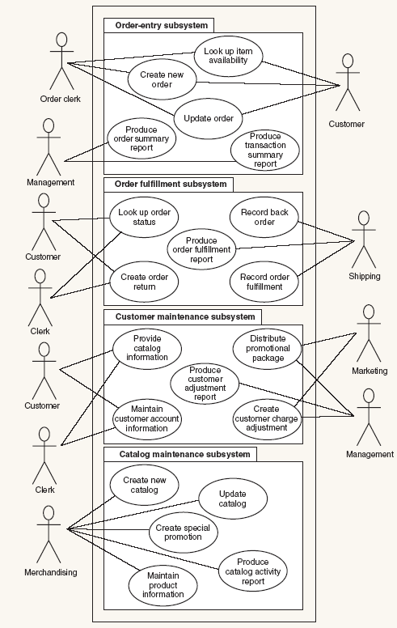
Figure 2.1: Use Case Diagram of <Name of the System>

  - Product Perspective
This subsection of the SRS should put the product into perspective with other related products. If the product is independent and totally self-contained, it should be so stated here. If the SRS defines a product that is a component of a larger system, as frequently occurs, then this subsection should relate the requirements of that larger system to functionality of the software and should identify interfaces between that system and the software.
A goal diagram (as example below) showing the major components of the larger system, interconnections, and external interfaces can be helpful
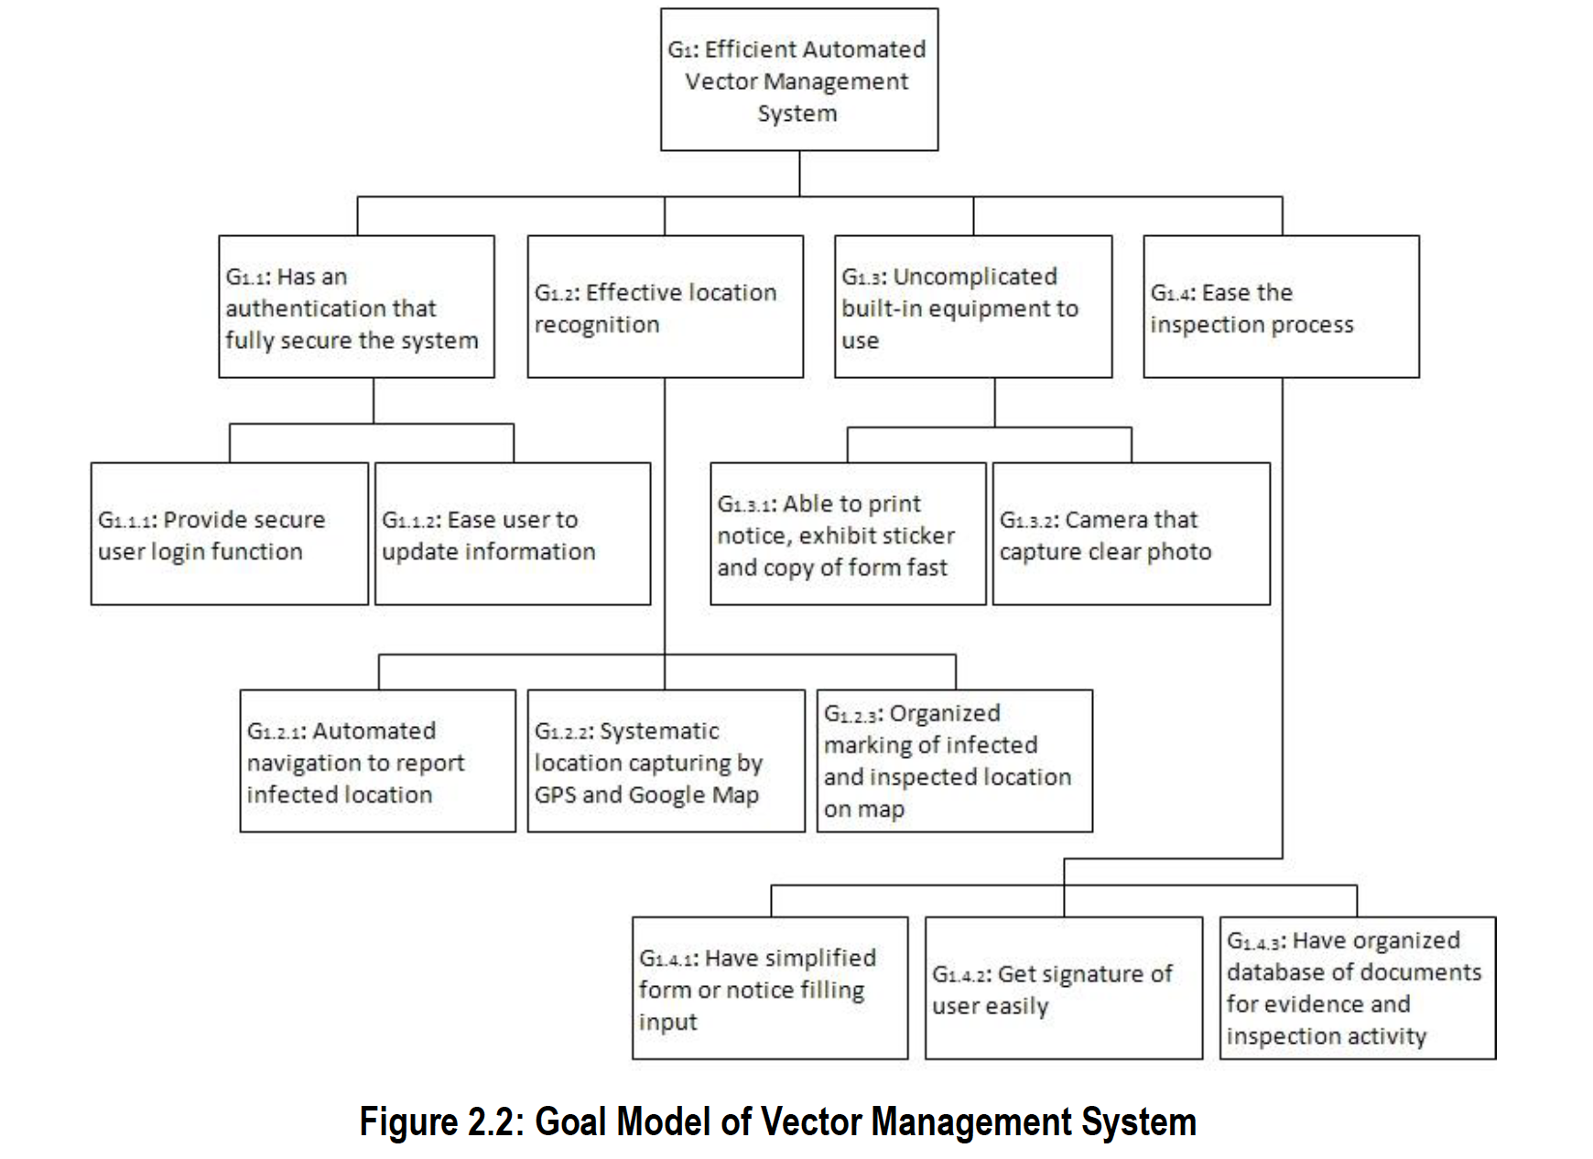.
[Organize as below 2.1.1 to 2.1.8]
Explain the perspective of the software product here by describing the goal diagram.

  - Product Functions
This subsection of the SRS should provide a summary of the major functions that the software will perform. For example, an SRS for an accounting program may use this part to address customer account maintenance, customer statement, and invoice preparation without mentioning the vast amount of detail that each of those functions requires.
Sometimes the function summary that is necessary for this part can be taken directly from the section of the higher-level specification (if one exists) that allocates particular functions to the software product. Note that for the sake of clarity:
- The functions should be organized in a way that makes the list of functions understandable to the customer or to anyone else reading the document for the first time.
- Textual or graphical methods can be used to show the different functions and their relationships. Such a diagram is not intended to show a design of a product, but simply shows the logical relationships among variables.

Summarize the major functions (by use case including the misuse case) of the system by referring to the use case diagram, Figure 2.1.

  - User Characteristics
This subsection of the SRS should describe those general characteristics of the intended users of the product including educational level, experience, and technical expertise. It should not be used to state specific requirements, but rather should provide the reasons why certain specific requirements are later specified in Section 3 of the SRS.
Describe here...

  - Constraints
This subsection of the SRS should provide a general description of any other items that will limit the developer’s options. These include:
- Regulatory policies;
- Hardware limitations (e.g., signal timing requirements);
- Interfaces to other applications;
- Parallel operation;
- Audit functions;
- Control functions;
- Higher-order language requirements;
- Signal handshake protocols (e.g., XON-XOFF, ACK-NACK);
- Reliability requirements;
- Criticality of the application;
- Safety and security considerations.

State here…

  - Assumption and Dependencies
This subsection of the SRS should list each of the factors that affect the requirements stated in the SRS. These factors are not design constraints on the software but are, rather, any changes to them that can affect the requirements in the SRS. For example, an assumption may be that a specific operating system will be available on the hardware designated for the software product. If, in fact, the operating system is not available, the SRS would then have to change accordingly.
List the factors here…

Specific Requirements
This section of the SRS should contain all of the software requirements to a level of detail sufficient to enable designers to design a system to satisfy those requirements, and testers to test that the system satisfies those requirements. Throughout this section, every stated requirement should be externally perceivable by users, operators, or other external systems. These requirements should include at a minimum a description of every input (stimulus) into the system, every output (response) from the system, and all functions performed by the system in response to an input or in support of an output.
[Include domain model i.e. class diagram without the operation part – only attributes without details on visibility and type, explain each class and its attributes including the relationships among the classes, see the example of Customer Support System. The diagram must be assigned a unique id]
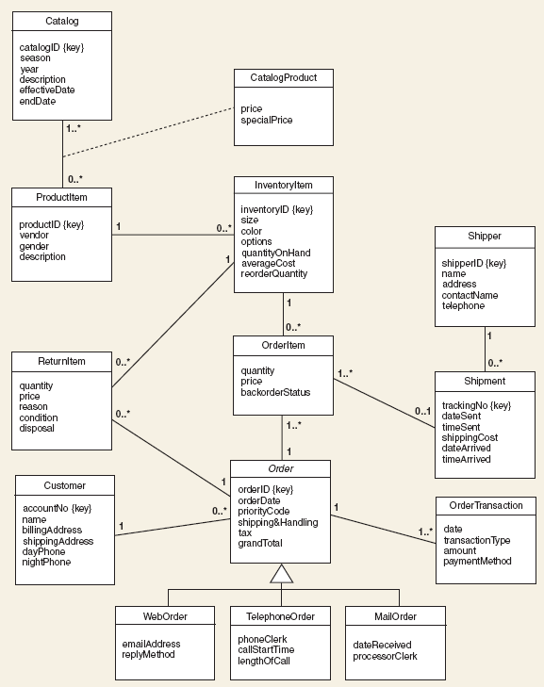
DM001 - Domain Model of <Name of the System>

[Include behaviour model of selected class i.e. UML state transition diagrams, see the example of TrainDoor Class below. Each state transition diagram must be assigned its own unique id. Briefly describe the state diagram.]

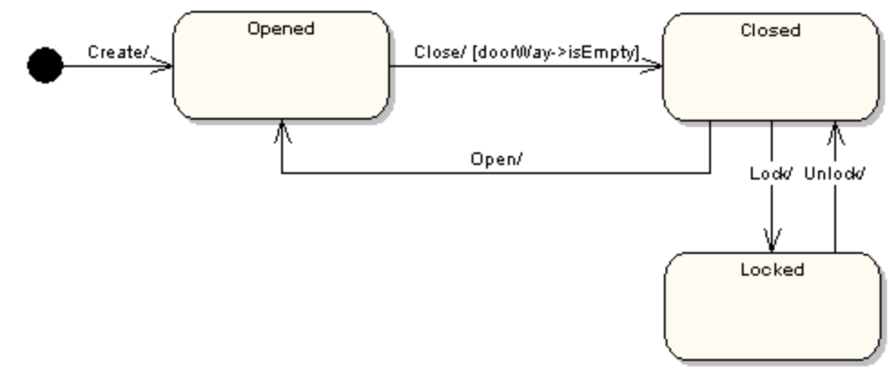
STD001 - State Transition Diagram of <Name of the Class>

As this is often the largest and most important part of the SRS, the following principles apply:
- Specific requirements should be stated in conformance with all the characteristics described in 4.3. (IEEE Std 830-1998)
- Specific requirements should be cross-referenced to earlier documents that relate.
- All requirements should be uniquely identifiable. [Provide ID to each functional requirement]
- Careful attention should be given to organizing the requirements to maximize readability.
[Section 3.1.1 to Section 3.1.4 provide the details of what described in 2.1.2 to 2.1.5. Consider to organize Section 3.2 by the modules i.e. map each feature with each module and map respective use case in the module with its functional requirement. For each functional requirement, indicate its details using use case description. Include activity diagram for each use case i.e. functional requirement.]

  - External Interface Requirements
    - User Interfaces
Provide all user interface designed in the proposed system.

    - Hardware Interfaces
Provide the details

    - Software Interfaces
Provide the details

    - Communication Interfaces
Provide the details

  - System Features
    - Module <Name of Module1>
State briefly the functional requirements (use cases) that are available in this module. Better to include the diagram of the specific module (or the example of Customer Support System – by subsystem, see example below) from the overall use case diagram in Figure 2.1.
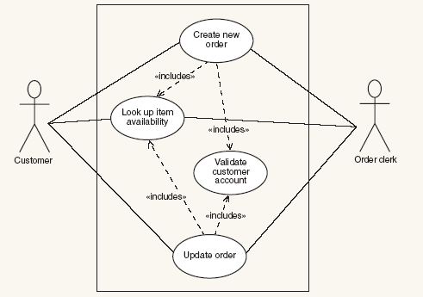
Figure 3.2: <Name of the Module/Sub-System e.g. Order Entry Subsystem>

      - UC001: Use Case <Name of Use Case1>
Provide code for each use case such as UC001 and so on… Include Use Case Specification (UCS) for each use case as in the example below. Ensure each use case has its own unique ID and the name of the heading above corresponds to the name of use case in the use case diagram (refer to Figure 2.1).

Include the respective Misuse Case Specification and Security Use Case Specification for related use case as well.

Refer to Table 3.1 for improvised UCS in terms of enhancement for attributes elements i.e., history log (version), traceability (author, checker, date creation/updated/revision), related requirements (ID, Natural Language-NL requirement specification for functional, quality & constraints types, priority based on Kano-types)

Table 3.1: Use Case Specification for <Name of Use Case>
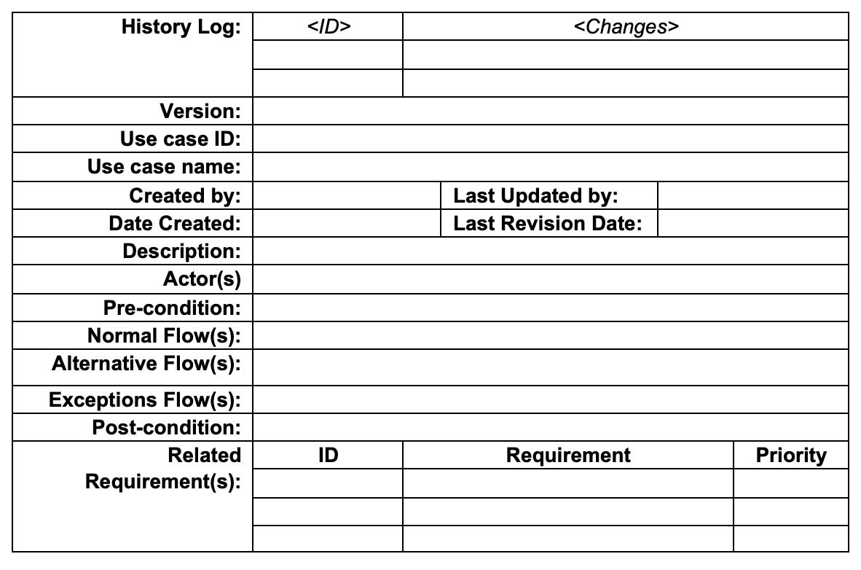
Example of Use Case Specification for Manage Delivery Order
History Log: | 1.0  1.1  1.2  2.0 | Create initial use case  Fixed pre-conditions  Fixed normal flow  Added related requirements
Version: | 2.0
Use Case ID: | UC-009
Use Case Name: | Manage Delivery Order
Created By: | Pang Cheng Hao |  |  | Last Updated By: | Pang Cheng Hao
Date Created: | 28 April 2016 |  |  | Last Revision Date: | 14 May 2016
Actors: | Marketing OC, Plantation OC
Description: | This use case describes how the Plantation OC and Marketing OC manage DO.
Pre-conditions: | - The Marketing and Plantation OC must first login into the plantation management system  - The Marketing or Plantation OC clicks on “Manage DO” button.
Normal Flow: | - The system displays DO list. (See E.1)  - The Marketing or Plantation OC select desired DO.  - The system displays the DO.  - The system displays 2 option buttons “Edit” and “Delete”.  - The Marketing or Plantation OC clicks on option button. (See A.1, A.2)
Alternative Flow: | A.1 Edit DO  - The Marketing or Plantation OC clicks “Edit” button.  - The system permits Marketing or Plantation OC to edit.  - The Marketing or Plantation OC edits DO content.  - The Marketing or Plantation OC clicks “Save” button.  - The system saves edited DO into system database.  - The Marketing or Plantation OC clicks “Print” button.  - The system clicks “Print” button. (See E.2)  - Return to normal flow step 3. (See NF 1.0)  A.2 Delete DO  - The Marketing or Plantation OC clicks “Delete” button.  - The system displays delete confirmation window with 2 buttons “Confirm” and “Delete”.  - If the Marketing or Plantation OC clicks “Cancel”,  - Return to normal flow step 3. (See NF 1.0)  - If the Marketing or Plantation OC clicks “Confirm”,  - The system deletes the DO from system database.  - Return to normal flow step 3. (See NF 1.0)
Exception: | E.1 No DO found in system database  - The system displays “No DO found in system database” message.  - Return to normal flow step 3. (See NF 1.0)  E.2 Fail to print DO  - The system displays “Fail to print DO! Please check printer.” Message.  - Return to normal flow step 3. (See NF 1.0)
Post-conditions: | The Marketing OC or Plantation OC successfully managed the DO.
Related Requirement: | ID |  | Requirement |  |  | Priority
Related Requirement: | FR UC-003-01 |  | The system shall be able to display the list of created DO in the system database |  |  | Basic
Related Requirement: | FR UC-003-02 |  | The system shall be able to display the created DO in the system database |  |  | Basic
Related Requirement: | FR UC-003-03 |  | The system shall be able to allow Marketing and Plantation OC to enter details into the DO form |  |  | Basic
Related Requirement: | FR UC-003-04 |  | The system shall allow Marketing and Plantation OC to print the created DO |  |  | Excitement
Related Requirement: | FR UC-003-05 |  | The Marketing and Plantation OC should be able to delete the created DO from the system database |  |  | Basic
Related Requirement: | QR UC-003-01 |  | The system shall be able to display error message when no DO found in system database and fail to print DO |  |  | Performance
Related Requirement: | CR UC-003-01 |  | The system shall prompt confirmation for DO deletion before delete the DO |  |  | Performance
Related Requirement: | CR UC-003-01 |  | The Marketing and Plantation OC shall be able to print the DO after the DO has been successfully saved in system database |  |  | Performance

Include system activity diagram for each respective use case. See example below for Manage Delivery Order scenario.
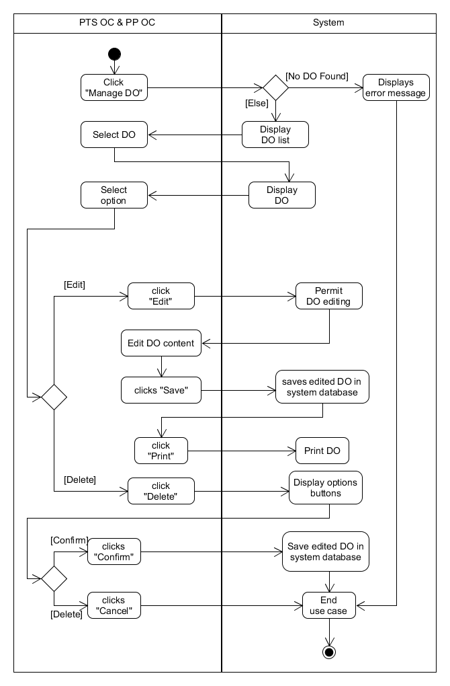
Figure 3.3: Activity Diagram of <Name of Use Case/Scenario if more than one scenario>

      - MC001: Misuse Case <Name of Misuse Case1>
Refer to Table 3.2 for the improvised Misuse Case Specification

Table 3.2 Misuse case Specification
Misuse Case ID | <unique ID of the misuse case>
Misuse Case Name | <A short active verb phrase>
Description | <Short description of the security threat or negative event>
Misuser/Threat Agent (s) | <Name of the unauthorized actor or external agent involved>
Threat | <The security vulnerability or flaw this misuse case exploits>
Triggers | <Event that initiates the execution of the misuse case (the attack start)>
Pre-Condition(s) | <Condition(s) that must be true before the misuse case can be executed (e.g., *System is online*, *Threat agent has network access*)>
Misuse Flow (Attack Steps) | <Description of the steps the misuser takes to execute the attack/harm>
Mitigation Flow(s) | <Description of alternative or option steps that could be taken by the system (or a legitimate user) to stop the attack mid-flow>
Exception Flow (s) | <Description of how the system handles critical errors during the attack and what prevents the attack from succeeding>
Post Condition (s) | <The resulting state of the system if the misuse case runs successfully (the harm done)>
Related Use Case(s) | <The legitimate use case(s) this misuse case threatens or is the inverse of>
Security Requirements | <The specific security requirement(s) that must be implemented to prevent this misuse case from occurring>

- Include the respective activity diagram for the misuse case

      - UC003: Use Case <Name of Use Case3>

    - Module <Name of Module2>
      - UC004: Use Case <Name of Use Case4>
      - UC005: Use Case <Name of Use Case5>

3.2.n Module <Name of the n Module>
…
  - Performance Requirements
State and refer to the specific functional requirement that is related to this non-functional requirement (if any).

  - Design Constraints
Explain any constraints imposed by the organization where the software product will be used such as the system must adhere to certain organizational standard and other related non-functional requirements.

  - Software System Attributes
Indicate any specific attributes that the customers/users request such as system must be attractive and easy to use for any specific customers.

  - Other Requirements
State here other quality characteristics or non-functional requirements for either customers/users or developers such as adaptability, flexibility, interoperability, maintainability, portability, reliability, reusability and usability.

Appendices
[Include any related documents, screenshots of legacy system, interview and survey questionnaires – that were observed and compiled to understand the system and it’s relevant context – boundary, scope, objects, interfaces]
- Appendix A: Originality/Similarity Report
  - Attach the originality/ similarity report (.pdf file) from Turnitin checking.
  - UTM teaching and learning best practice for plagiarism policy is similarity index must less than (=<) 20%
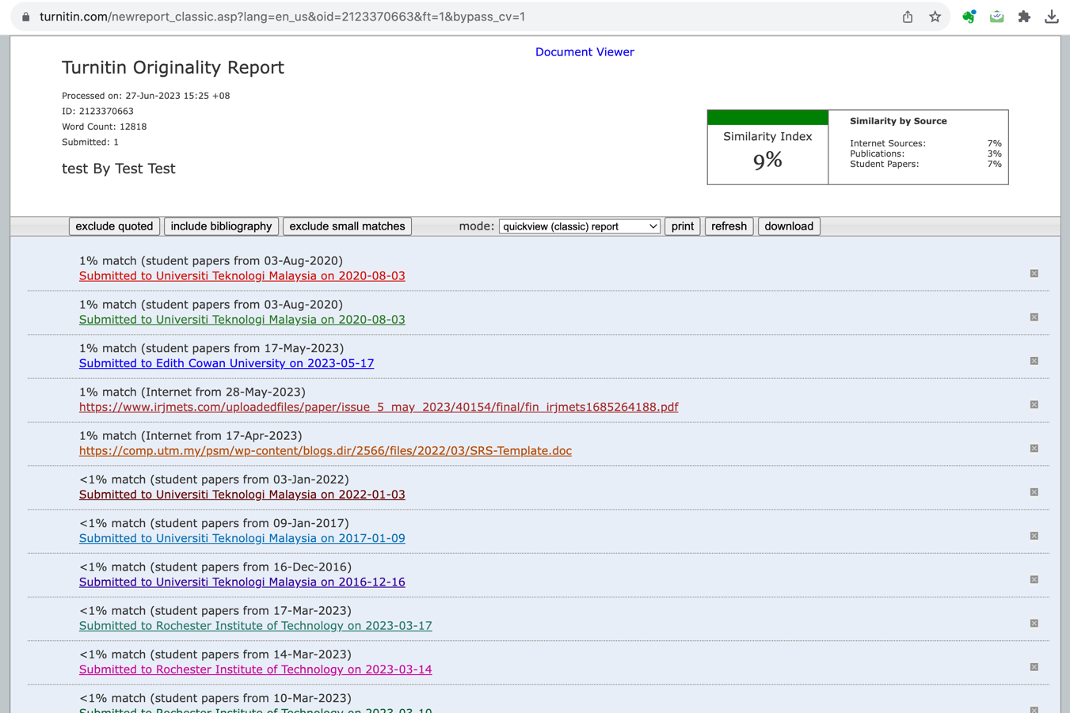

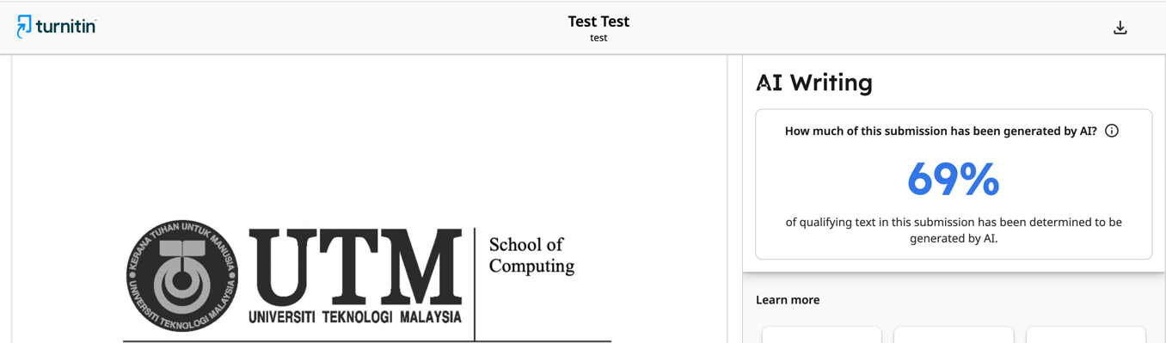

- Appendix B: List of Prompts Used
  - Include verifiable evidence of the use of Generative AI tools such as ChatGPT, QuillBot, etc., in the creation of your assignment.
  - This evidence may include screenshots and URL links
  - Failure to provide this evidence when actually you are using generative AI in your work will result in ethical violations and may lead to plagiarism penalties, ultimately resulting in a grade deduction to zero marks.

* Generative Artificial Intelligence refers to a type of artificial intelligence technology that can produce various types of content, including text, images, audio, and synthetic data
Example: Screenshot
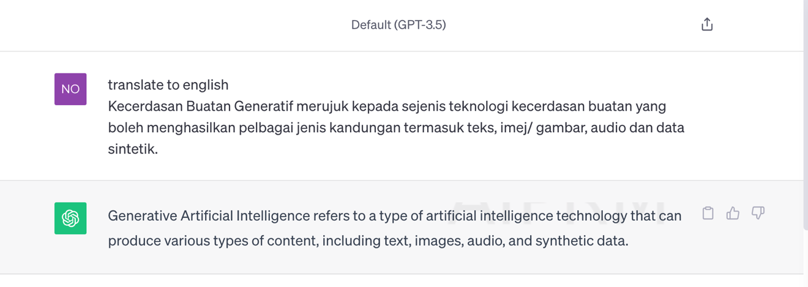
Figure: Screenshot Generative AI translation from BM to English
Example: URL
https://chat.openai.com/share/0ff33fdd-9b7f-407c-9b74-b744ec698a7e>

